Issue Log Item 14: Surrender Validation
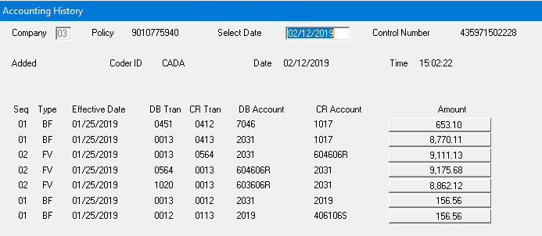
BF: 7046 – Int Income 1017 - Loan Interest
BF: 2031 – Surrender Clearing 1017 - Loan
FV: 2031 – Surrender Clearing 604606R - Surr ETI Renew
FV: 604606R - Surr ETI Renew 2031 – Surrender Clearing
FV:603606R – Surr Chrg Renew 2031 – Surrender Clearing
BF: 2031 – Surrender Clearing 2019 – Unapplied Cash
BF: 2019 – Unapplied Cash 406106S - Single Prem ETI 1/25/2019

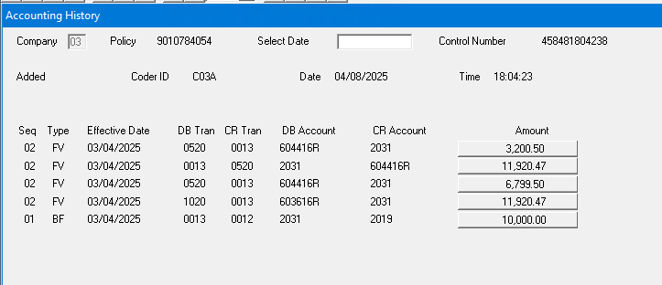
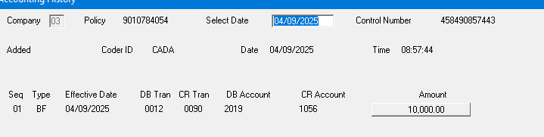
FV:604416R – Endowment 2031 – Surrender Clearing
FV: 2031 – Surrender Clearing 604416R – Endowment
FV: 604416R – Endowment 2031 – Surrender Clearing
FV: 603616R – Surr Charge Renew 2031 – Surrender Clearing
BF: 2031 – Surrender Clearing 2019 – Unapplied Cash 3/4/2025
BF: 2019 – Unapplied Cash 1056 - Payout 4/9/2025

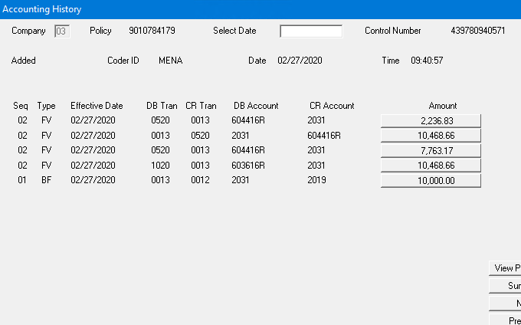
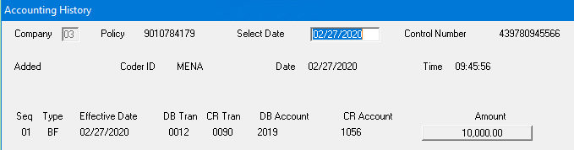

FV:604416R – Endowment 2031 – Surrender Clearing
FV: 2031 – Surrender Clearing 604416R – Endowment
FV: 604416R – Endowment 2031 – Surrender Clearing
FV: 603616R – Surr Charge Renew 2031 – Surrender Clearing
BF: 2031 – Surrender Clearing 2019 – Unapplied Cash
BF: 2019 – Unapplied Cash 1056 - Payout 2/27/2020

Issue Log Item 15: Orphan Payments
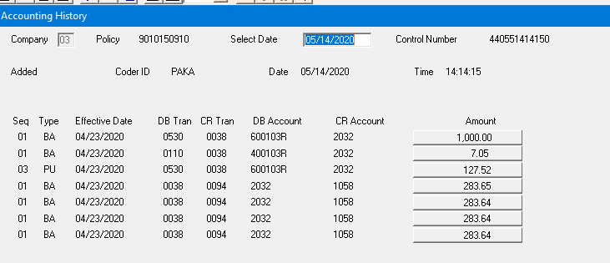
BA: 600103R – Death Ben - Ren 2032 – Death Clear
BA: 400103R – Renewal Prem 2032 – Death Clear
PU: 600103R – Death Ben - Ren 2032 – Death Clear $1,134.57 DB
BA: 2032 – Death Clear 1058 – Death Claim Pay
BA: 2032 – Death Clear 1058 – Death Claim Pay
BA: 2032 – Death Clear 1058 – Death Claim Pay
BA: 2032 – Death Clear 1058 – Death Claim Pay $1,134.57 in DB Payouts
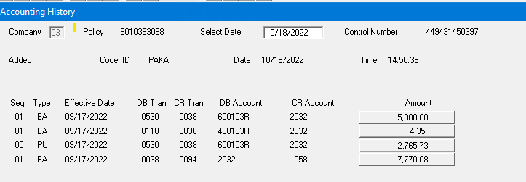
BA: 600103R – Death Ben - Ren 2032 – Death Clear
BA: 400103R – Renewal Prem 2032 – Death Clear
PU: 600103R – Death Ben - Ren 2032 – Death Clear $7,770.08 DB
BA: 2032 – Death Clear 1058 – Death Claim Pay $7,770.08 in DB Payouts
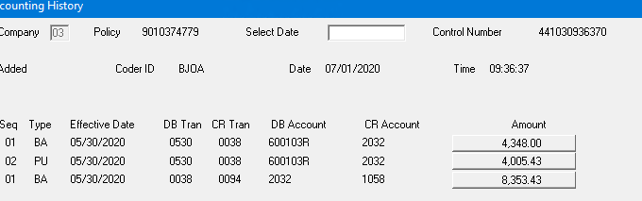
BA: 600103R – Death Ben - Ren 2032 – Death Clear
PU: 600103R – Death Ben - Ren 2032 – Death Clear $8,353.43 DB
BA: 2032 – Death Clear 1058 – Death Claim Pay $8,353.43 in DB Payouts

Issue Log Item 16: Unbalanced Claims
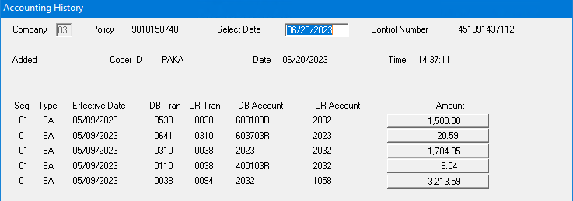
BA: 600103R – Death Ben - Ren 2032 – Death Clear
BA: 603703R – Int Div Dep RN 2023 – Div Left on Dep = Not a DB Transaction
BA: 2023 – Div Left on Dep 2032 – Death Clear DB Trans = $1,500+$1,704.05+$9.54
BA: 400103R – Renewal Prem 2032 – Death Clear = $3,213.59
BA: 2032 – Death Clear 1058 – Death Claim Pay $3,213.59 in DB Payouts

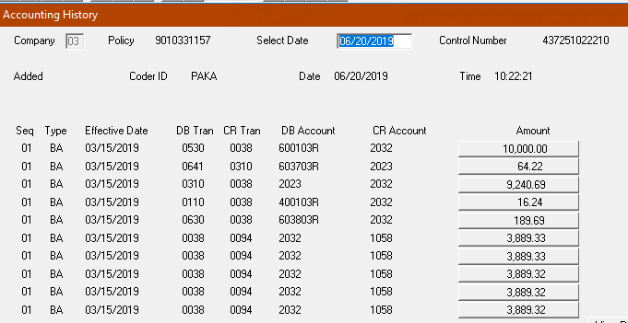

BA: 600103R – Death Ben - Ren 2032 – Death Clear
BA: 603703R – Int Div Dep RN 2023 – Div Left on Dep = Not a DB Transaction
BA: 2023 – Div Left on Dep 2032 – Death Clear
BA: 400103R – Renewal Prem 2032 – Death Clear DB Trans = $10,000+$9,240.69
BA: 603803R – Int Dth Ben RN 2032 – Death Clear +$16.24+$189.69= $19,446.62
BA: 2032 – Death Clear 1058 – Death Claim Pay
BA: 2032 – Death Clear 1058 – Death Claim Pay
BA: 2032 – Death Clear 1058 – Death Claim Pay
BA: 2032 – Death Clear 1058 – Death Claim Pay
BA: 2032 – Death Clear 1058 – Death Claim Pay $19,446.62 in DB Payouts

9010335038 – No Accounting Available. Status is Terminated Death Claim as of 4/22/2018

Issue Log Item 18: Potential Missing Claims
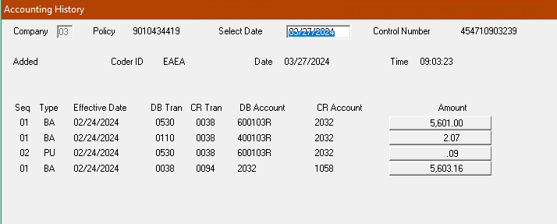
BA: 600103R – Death Ben - Ren 2032 – Death Clear
BA: 400103R – Renewal Prem 2032 – Death Clear
PU: 600103R – Death Ben - Ren 2032 – Death Clear $5,603.16DB
BA: 2032 – Death Clear 1058 – Death Claim Pay $5,603.16 in DB Payout
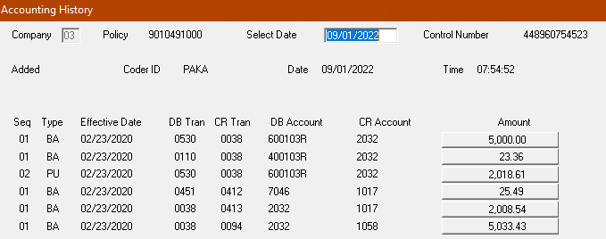
BA: 600103R – Death Ben - Ren 2032 – Death Clear
BA: 400103R – Renewal Prem 2032 – Death Clear
PU: 600103R – Death Ben - Ren 2032 – Death Clear $7,041.97 DB
BA: 7046 – Int Income 1017 - Loan Interest Loan Int included in final Loan
BA: 2032 – Death Clear 1017 – Loan $2,008.54 + $5,033.43 =
BA: 2032 – Death Clear 1058 – Death Claim Pay $7,041.91 DB + Loan Payout
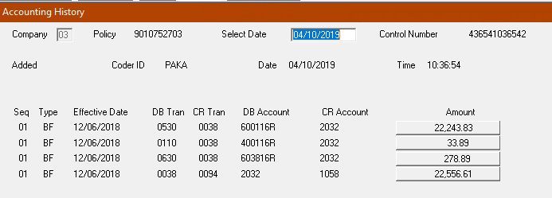
BF: 600116R – Death Ben - Ren 2032 – Death Clear
BF: 400116R – Renewal Prem 2032 – Death Clear
BF: 603816R – Int Dth Ben RN 2032 – Death Clear
BA: 2032 – Death Clear 1058 – Death Claim Pay $22,556.61 DB

Issue Log Item 19: Payee/Beneficiary Validation
010807842C – Patricia Mayhew was the insured. Amount is correct, but Payee was:
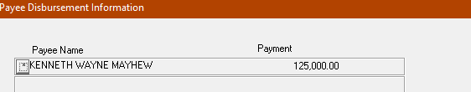
011054986C – Amount and Payee are correct
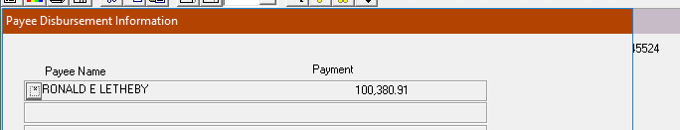

010724403C – Amount and Payee are correct
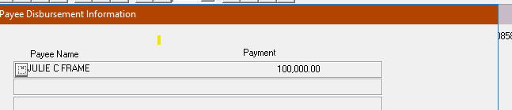

010752477C – Amount and Payee are correct
